Data Acquisition and Preprocessing

2.1 Selection of Public Proteomics Database
Public proteomics databases play a crucial role in ensuring transparency, reproducibility, and reuse of mass spectrometry data. For this study, the proteomics dataset was selected based on the reference article “Identification of Cancer-Associated Proteins in Colorectal Cancer Using Mass Spectrometry”, published in Proteomes (2025). The authors of this article deposited their raw and processed data in the ProteomeXchange Consortium, which is the most widely accepted global infrastructure for proteomics data sharing.

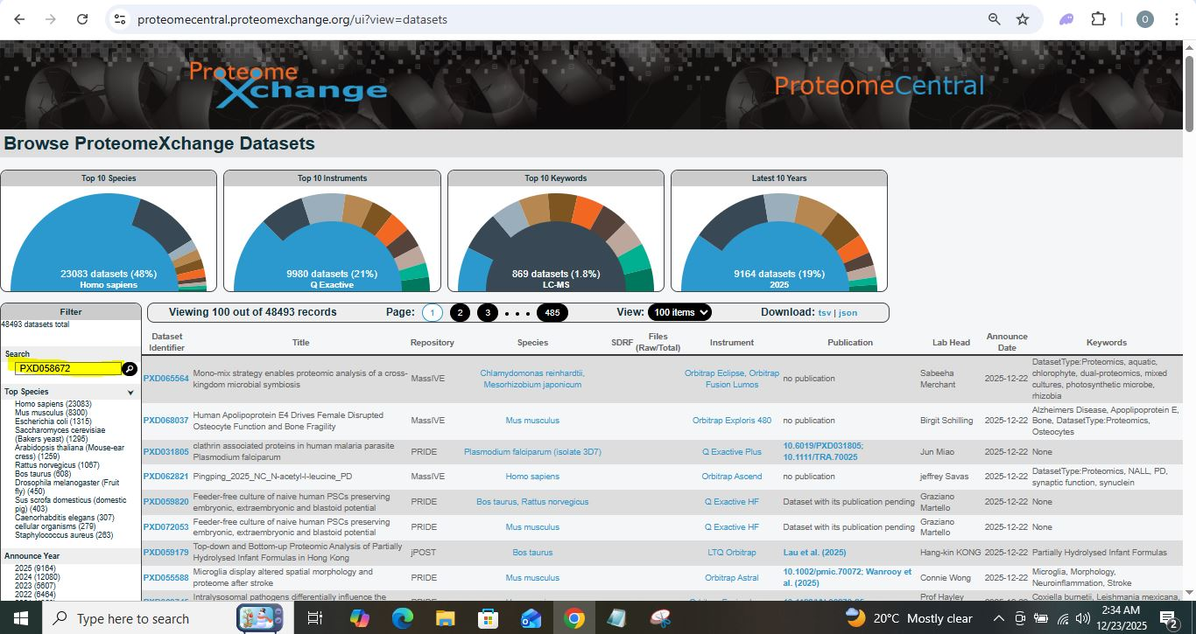

ProteomeXchange was chosen because it hosts peer-reviewed, publicly accessible datasets that are directly linked to published research articles. The dataset used in this study carries the identifier PXD058672, which is explicitly cited in the reference paper.

2.2 Hosting Repository: jPOSTrepo

Although ProteomeXchange acts as a central index, the actual data files are hosted by partner repositories. In this case, the dataset PXD058672 is hosted by jPOSTrepo under the identifier JPST003422. jPOSTrepo is a member repository of the ProteomeXchange Consortium and is maintained by the Japanese ProteOme STandard Repository.

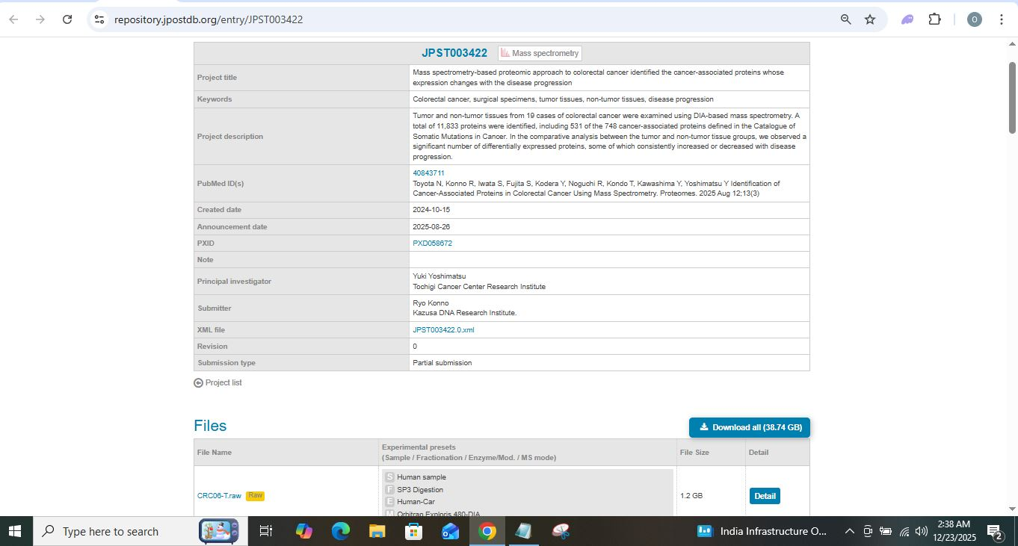

The jPOSTrepo project page clearly lists tumor and non-tumor colorectal cancer samples, confirms the DIA acquisition mode, and provides links to all associated raw and processed files. This makes the repository particularly suitable for educational and reproducibility-focused proteomics studies.

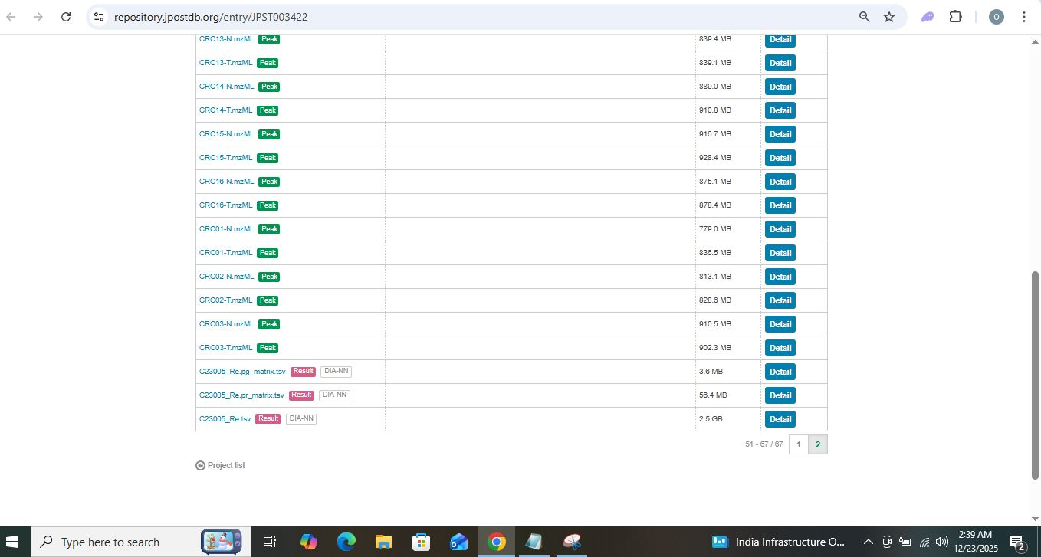
In this chapter, the data acquisition process was performed by referring to the published article. The dataset mentioned in the article was located in ProteomeXchange and accessed via the jPOST repository. The available data files, including primary DIA data (mzML) and processed DIA-NN result files, were identified.

2.3 Summary
In this chapter, the data acquisition process was performed by referring to the published article. The dataset mentioned in the article was located in ProteomeXchange and accessed via the jPOST repository. The available data files, including primary DIA data (mzML) and processed DIA-NN result files, were identified using browser-based methods.

The scope of this chapter is limited to identifying the referenced dataset, accessing the public repository, and understanding the types of data available for downstream proteomics analysis.

